Seawater Intrusion Assessment (2030) – Methodology and Trends
Seawater intrusion vulnerability for 2030 was assessed using an integrated conceptual framework combining IPCC AR6 sea-level rise projections, coastal proximity influence, and projected groundwater depth dynamics. Scenario-based sea-level rise values were spatially distributed inland using a normalized distance-to-coast influence factor to represent declining marine pressure with distance from the shoreline. Groundwater susceptibility was incorporated through projected Depth to Water Table (DTW), estimated by applying baseline groundwater decline rates and population-driven abstraction pressure to current DTW conditions. The combined analysis captures both marine forcing and terrestrial groundwater stress influencing saline intrusion potential. Results indicate elevated intrusion risk along coastal and deltaic districts of Sindh, with risk extending inland where groundwater levels are shallow and abstraction pressure is high, highlighting zones of compounded vulnerability by 2030.
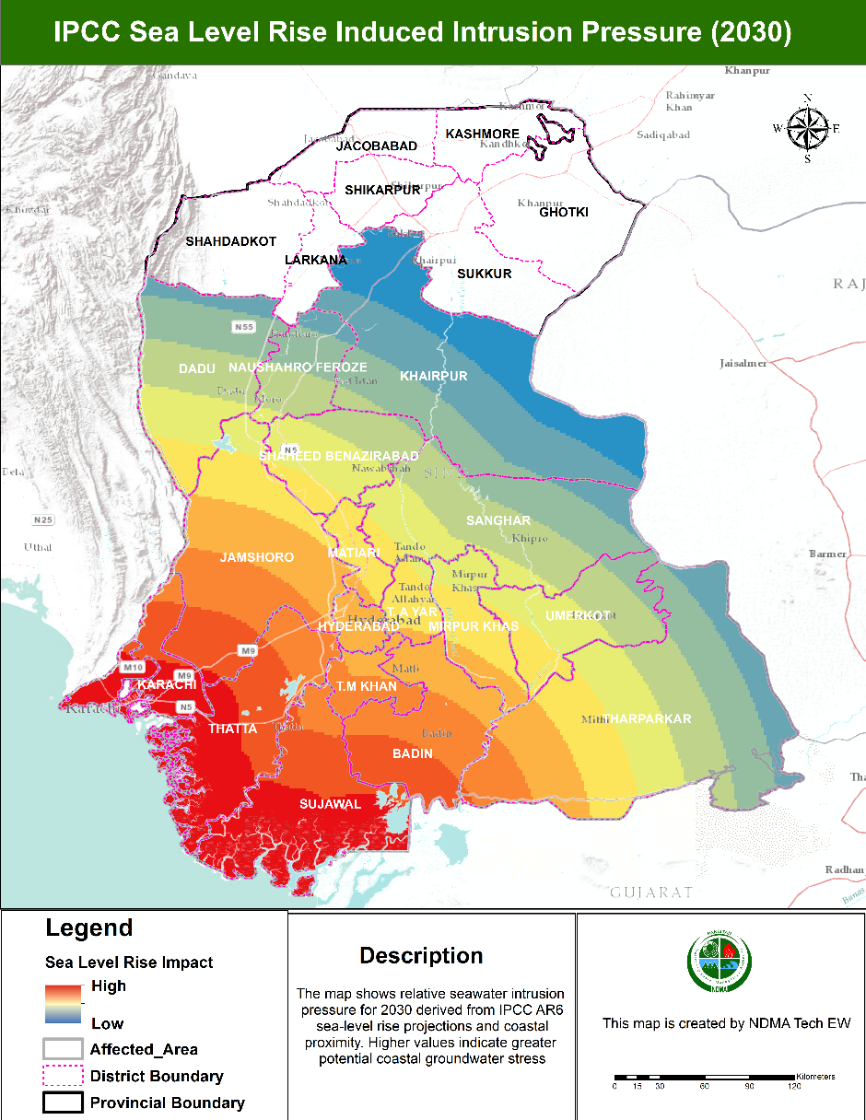
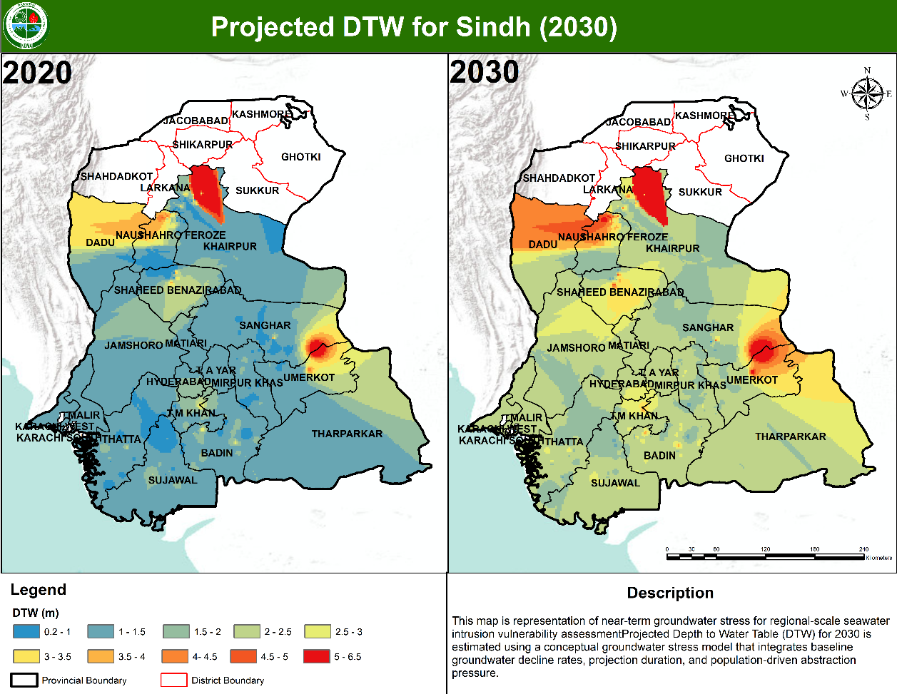
Coastal Erosion Trends along the Sindh Coast Based on DSAS WLR Analysis
Shoreline change analysis along the Sindh coast was conducted using NASA’s Digital Shoreline Analysis System (DSAS), employing the Weighted Linear Regression (WLR) method to quantify long-term shoreline movement while accounting for positional uncertainty in multi-temporal shoreline datasets. The WLR results indicate that extensive sections of the Sindh coastline, particularly the Indus Delta region encompassing Thatta and Sujawal districts, are experiencing persistent and statistically robust erosion, characterized by negative shoreline change rates. Higher erosion magnitudes are observed in low-lying deltaic zones where reduced sediment discharge from the Indus River, combined with tidal forcing and relative sea-level rise, amplifies shoreline retreat. In contrast, localized accretion or reduced erosion rates are identified near structurally modified coastlines, notably around Karachi, reflecting the influence of coastal engineering and urban development. Overall, the WLR-based analysis demonstrates a dominance of erosional trends over accretion along the Sindh coast, underscoring increasing coastal instability and heightened vulnerability to future sea-level rise and seawater intrusion.




